Physics 30 Lessons 1 to 12 Review

- A 1700 kg car moving at 22.0 km/hr is struck directly from behind by a 2100 kg truck moving at 25.0 km/hr. After the collision, the car is moving at 31.0 km/hr in the original direction.
a. What is the impulse given to the car? (15300 kg⋅km/h or 4250 kg⋅m/s)
b. If the collision lasted for 0.8 seconds, calculate the average force acting on the car. (5312.5 N)

- A 2575 kg van runs into the back of a 825 kg car that was at rest. They move off together at 8.5 m/s. What was the initial speed of the van? (11 m/s)

- An object travelling east at 40 m/s and having a mass of 50 kg collides with an object with a mass of 40 kg and travelling east at 20 m/s. If they stick together on contact what is the resultant velocity of the combined mass? (31.1 m/s east)

- A small rocket with a mass of 28.0 kg is moving East at a speed of 60 m/s. The rocket suddenly breaks into two pieces (11.0 kg and 17.0 kg). If the velocity of the 11.0 kg piece is 97.8 m/s at 30º above the horizontal, what is the velocity of the other piece? (54.2m/s at 35.7º below the horizontal)

- A mass of 50 kg travelling north at 45 m/s collides with a mass of 60 kg travelling west at 50 m/s. If they stick together on contact, what is the resulting velocity of the combined masses? (34.1 m/s at 37˚ N of W)

- What is the size of the image of a person that is 1.75 m tall and is standing 8 m from a pinhole camera that is 20 cm long? (4.4 cm)

- When verifying the speed of light, a student set up a hexagonal rotating mirror and a reflecting mirror 40 km away. At what minimum frequency must the mirror rotate so that the reflected light is seen by the observer? (625 Hz)

- Two mirrors meet at a 135˚ angle. If light rays strike one mirror at 40˚, at what angle do they leave the second mirror? (5˚)
• •
C f

- Draw a ray diagram for the following concave mirror. Describe the image. (smaller, inverted, real)

- A 1.50 cm high diamond ring is placed 20.0 cm from a concave mirror with radius of curvature of 30.0 cm. Determine (a) the position of the image, and (b) it’s size. (60 cm, 4.5 cm)
- A 1.00 cm high object is placed 10.0 cm from a concave mirror whose radius of curvature is 30.0 cm.
  - Draw a ray diagram to locate (approximately) the position of the image.
  - Determine the position of the image and the magnification analytically.(-30cm, 3)

- An external rearview car mirror is convex with a radius of curvature of 16.0 m. Determine the location of the image and its magnification for an object 10.0 m from the mirror. (-4.44 m, 0.44)

- Light traveling in air strikes a flat piece of thick glass at an incident angle of 60˚. If the index of refraction in the glass is 1.50, (a) what is the angle of refraction in the glass and (b) what is the angle at which the ray emerges from the glass? (35.28˚, 60˚)

- Light is incident on an equilateral glass prism at a 40.0˚ angle to one face. Calculate the angle at which light emerges from the opposite face. Assume that n = 1.58 for the prism. (35.6˚)

- A beam of light is emitted 8.0 cm beneath the surface of a liquid and strikes the surface 7.0 cm from the point directly above the source. If total internal reflection occurs, what is the index of refraction of the liquid? (1.52)

- What is (a) the position and (b) the size of the image of a 7.6cm high flower placed 1.00m from a convex camera lens with a focal length of 50.0 mm? (5.26cm, 0.40cm)

- An object is placed 10 cm from a converging lens with a focal length of 15 cm. Determine the image position and size (a) analytically, and (b) using a ray diagram. (-30 cm, 3 times bigger)

- Where must a small insect be placed if a diverging lens with a focal length of 25 cm is to form a virtual image that is 20 cm in front of the lens? (100 cm)

- An object appears red in white light. What colour will it appear to be if it is illuminated by (a) magenta light, (b) cyan light, and (c) yellow light?

- How can you tell if a pair of sunglasses is polarizing or not?

- At what angle will 560 nm light produce a second order maximum when passing through double slits that are 1.45 × 10⁻² cm apart? (4.43˚)

- An interference pattern is formed on a screen when a light of wavelength 648 nm is directed through two slits. If the slits are 52 μm apart and the screen is 3.5 m away, what will be the separation between bright fringes? (4.36 cm)

- A 3500 line/cm grating produces a third-order fringe at a 28.0˚ angle. What wavelength of light is being used? (447 nm)

- Light with a frequency of 5.78 × 10¹⁴ Hz is directed onto a diffraction grating ruled with 8000 lines/m. What is the distance between the 2rd bright band and the 5th dark band of the interference pattern formed on a screen 3.0 m from the grating? (3.11 cm)
Old diploma exam questions

Use the following information to answer the next four questions.

Deployment of Air Bags

Air bags are designed to deploy when a car, moving at a minimum speed of 18 km/h, comes to a crashing stop. The impact sensor, also moving at 18 km/h, consists of a small steel ball of 0.050 kg, which is held in position by a magnet, as shown above. On impact, the ball breaks free in 1.00 × 10⁻³ s and slides within a cylinder. The ball makes contact with two electrodes at the end of the cylinder, thus activating the air bag.

- What is the magnitude of the force required to break away from the magnet?
A. 2.5 × 10⁵ N
B. 1.3 × 10⁵ N
C. 2.5 × 10² N
D. 1.3 × 10² N

- If the car was moving at 18 km/h, the maximum speed of the ball immediately after impact would be
A. 62 m/s
B. 18 m/s
C. 5.0 m/s
D. 0 m/s

- If the car was initially moving at 18 km/h, the driver had a mass of 70 kg, and the air bag stopped him in 0.10 s, the magnitude of the force acting on the driver during the deceleration would be
A. 1.3 × 10⁴ N
B. 3.5 × 10³ N
C. 1.3 × 10³ N
D. 3.5 × 10² N

- The entire process, from impact to air bag inflation, takes less than 3.0 × 10⁻³ s. During this same time, how far forward would a passenger who was not wearing a seat belt move?
A. 1.5 × 10⁻² m
B. 1.8 × 10⁻² m
C. 5.0 m
D. 0 m
_______________________________

- The physical quantity that can have the same unit as impulse is
A. force
B. work
C. power
D. momentum

Use the following information to answer the next question.

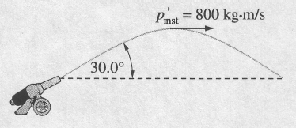

- A 2.00 kg cannonball is fired out of a cannon at an angle of 30.0° to the horizontal. When the cannonball reaches the top of its path, its momentum has a magnitude of 800 kg⋅m/s. What was the horizontal component of the cannonball's momentum when it left the cannon?
A. 461 kg⋅m/s
B. 800 kg⋅m/s
C. 924 kg⋅m/s
D. 1 600 kg⋅m/s

Numerical Response

- In a vehicle safety test, a 1 580 kg truck travelling at 60.0 km/h collides with a concrete barrier and comes to a complete stop in 0.120 s. The magnitude of the change in the momentum of the truck, expressed in scientific notation, is _____ × 10^{w} kg·m/s.

(Record your three-digit answer in the numerical-response section on the answer sheet.)

Use the following information to answer the next two questions.

A 1 000 kg car travelling east at 29.4 m/s on an icy road hits a parked truck that has a mass of 1 500 kg. Immediately after the collision, the car was moving at 20.0 m/s in the direction 20.0º N of E, and the truck was moving at an unknown speed in the direction 45.0º S of E.

- What physics principles do police use to determine the speed of the truck?
A. Conservation of kinetic energy but not conservation of momentum
B. Conservation of momentum but not conservation of kinetic energy
C. Both conservation of momentum and conservation of kinetic energy
D. Neither conservation of momentum nor conservation of kinetic energy

Numerical Response

- The magnitude of the total momentum before the collision, expressed in scientific notation, is a.bc × 10^{d} kg·m/s. The values of a, b, c, and d are _____, _____, _____, and _____ .

(Record all four digits in the numerical-response section on the answer sheet.)

_______________________________

- A rocket travelling away from Earth at a speed of 520 km/s emits an intense pulse of light every 24 hours exactly. After six days, astronomers on Earth observe that a pulse is delayed by approximately
A. 1 s
B. 5 s
C. 150 s
D. 900 s

- The scientists who made the first successful observations and calculations of the speed of light were
A. Römer and Huygens
B. Huygens and Newton
C. Galileo and da Vinci
D. Michelson and Morley

Use the following information to answer the next question.

Measuring the Speed of Light
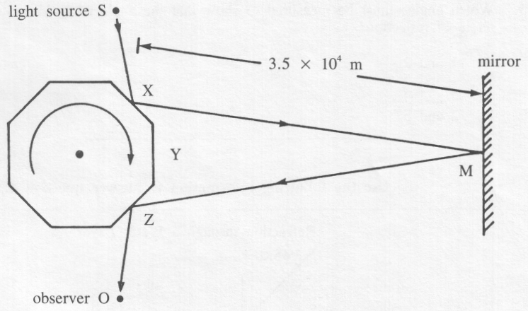

When the eight-sided mirror is stationary, light travels from S to X to M to Z to O. The distance XM is 3.5 × 10⁴ m. When the eight-sided mirror is rotating, provided that the speed of rotation is correctly adjusted, light travels from S to X to M to Y to 0 (since Y will have moved to Z).

- The eight-sided mirror rotates at 480 rev/s. The speed of light calculated from this information is
A. 3.0 × 10⁸ m/s
B. 2.7 × 10⁸ m/s
C. 1.7 × 10⁷ m/s
D. 4.2 × 10⁶ m/s
____________________________________

- The first calculations that gave an estimate of the speed of light used measurements of the
A. light transmitted through a rotating toothed wheel
B. time required for light to travel across the Earth's orbit
C. divergence of a ray of light reflected off a rotating mirror
D. time delay between flashes of light from two lanterns on separate hills

Use the following information to answer the next question.

Refraction of Light in Glass
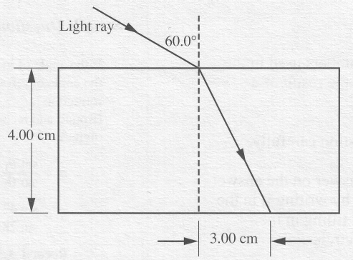

A light ray refracts when it enters a glass block from air.

Numerical Response

- The refractive index of the glass is _____ .

(Record your three-digit answer in the numerical-response section on the answer sheet.)

_______________________________

- Galileo was unsuccessful in his attempt to measure the speed of light because
A. he could not produce a suitable vacuum
B. he did not have lenses to produce a narrow parallel light beam
C. his reaction time was greater than the travel time of his light beam
D. the speed of light is so high that it cannot be measured without using electronic equipment

- When an object 30.0 cm high is placed 1.0 m from a pinhole camera, the image formed on the back of the camera 10.0 cm from the pinhole is
A. 3.0 cm high and erect
B. 3.0 cm high and inverted
C. 30.0 cm high and erect
D. 30.0 cm high and inverted

- A student measures the shadow of a building and finds it to be 10.5 m long. The student then measures the shadow of a vertical metre stick and finds it to be 1.25 m long. The height of the building is
A. 8.40 m
B. 9.25 m
C. 9.50 m
D. 13.1 m

Use the following information to answer the next question.

Law of Reflection
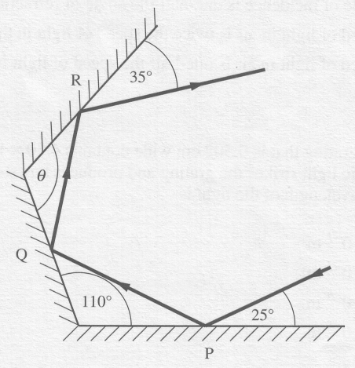
Three plane mirrors P, Q, and R are arranged as shown. The incident ray strikes mirror P at an angle of 25° and leaves mirror R at an angle of 35°.

- The angle θ between mirrors Q and R is
A. 90º
B. 100°
C. 110°
D. 120º
________________________________

- Frequency is more reliable than wavelength for classifying colors because wavelength changes during
A. refraction
B. diffraction
C. interference
D. polarization

Use the following information to answer the next question.

Properties of Light
I. Light can be polarized.
II. Light travels in straight lines.
III. Light can produce interference patterns.
IV. When light is reflected, the angle of incidence equals the angle of reflection.
V. Within optically dense materials, total internal reflection occurs for angles of incidence greater than a certain critical angle.

- The transmission of light through optical fibers depends on properties
A. I, II, and III
B. I, III, and V
C. II, IV, and V
D. III, IV, and V
__________________________________

- When monochromatic light passes from air into a glass prism, changes occur in
A. frequency and wavelength only
B. wave velocity and frequency only
C. wave velocity and wavelength only
D. frequency, wavelength, and wave velocity

Numerical Response

- A beam of infra-red radiation has a frequency of 2.12 × 10¹³ Hz. When this beam travels in a medium of refractive index 1.61, its wavelength, expressed in scientific notation, will be a.bc × 10^{-d} m. The values of a, b, c and d are ___, ___, ___, and ___.

(Record your four-digit answer in the numerical-response section on the answer sheet.)

- After light passes from air into a second medium, its speed is observed to be 2.0 × 10⁸ m/s. The index of refraction of the second medium is
A. 0.67
B. 1.3
C. 1.5
D. 6.0

Use the following information to answer the next question.

Light Incident on a Multilayer
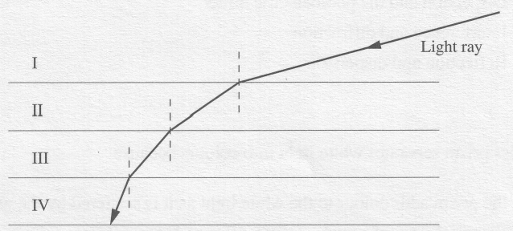
The diagram shows four layers of transparent liquids, one on top of the other. The liquids do not mix. An oblique ray of light travels through the liquids as shown.

- In which liquid is the speed of the light ray the slowest?
A. I
B. II
C. III
D. IV
_______________________________

- The critical angle for light passing from flint glass (n = 1.62) into water (n = 1.33) is
A. 55.2º
B. 48.8º
C. 38.1º
D. undefined

- If the incoming light ray makes an incident angle of 35º when entering a glass equilateral triangle prism (n = 1.50), what is the angle of refraction for the light ray as it emerges from the prism?
A. 11.3º
?
60º
35º
B. 36.8º
C. 48.6º
D. 66.0º

- Light behaves like a transverse wave. This is shown by experiments that demonstrate
A. reflection
B. refraction
C. interference
D. polarization

- When Iceland spar (calcite) produces two rays from one incident ray, the emergent rays
A. travel at different speeds in air
B. have different cross-sectional areas
C. are polarized in perpendicular planes
D. are longitudinal waves for one ray and transverse waves for the other

- When a light beam is split into two waves and the crest from one wave meets a trough from the other wave, the waves would be
A. in phase and produce destructive interference
B. in phase and produce constructive interference
C. out of phase and produce destructive interference
D. out of phase and produce constructive interference

Use the following information to answer the next question.

A PolaroidTM filter has one axis of polarization. This axis is represented in the diagram:
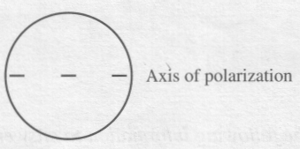

- The orientation that allows a minimum amount of light to pass through two such PolaroidTM filters is shown in
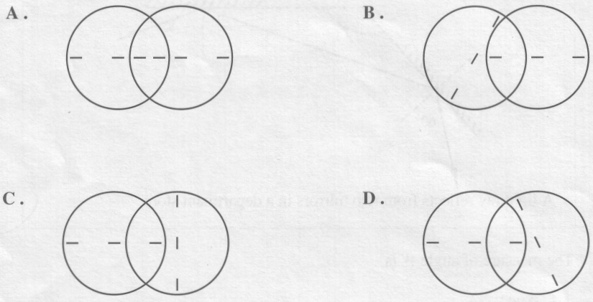

- Light passes through two slits separated by 5.0 × 10⁻⁴ m and produces an interference pattern on a screen 2.5 m away. If the first-order bright line is located 3.5 × 10⁻³ m from the central maximum, the wavelength of the light is
A. 4.0 × 10⁻⁷ m
B. 7.0 × 10⁻⁷ m
C. 4.0 × 10⁻⁴ m
D. 7.0 × 10⁻¹ m

- Light is incident normally on a grating with 5.0 × 10⁵ lines/m. If the first-order bright line is produced at an angle of 15° on a screen 1.30 m from the grating, the wavelength of light used is
A. 5.2 × 10⁻⁷ m
B. 1.3 × 10⁻⁵ m
C. 2.3 × 10⁻⁵ m
D. 5.8 × 10⁻⁴ m

- When they travel through the same doorway, sound waves diffract much more than visible light waves do because
A. the speed of light is much greater than that of sound
B. the wavelength of sound is much longer than that of light
C. light is a transverse wave but sound is a longitudinal wave
D. sound is a mechanical wave but light is an electromagnetic wave

- Monochromatic light strikes a diffraction grating of 0.25 mm spacing. The light passes through the grating to produce an interference pattern on a screen 3.0 m away. If 50 bright lines are produced over a 30 cm space, what is the frequency of the light?
A. 5.0 × 10⁻⁷ Hz
B. 1.5 × 10² Hz
C. 8.0 × 10⁸ Hz
D. 6.0 × 10¹⁴ Hz

- Which of the following is not true of plane mirrors and the images they form?
A. The light rays intersect at a point behind the mirror to form a real erect image.
B. The angles of incidence and reflection are equal.
C. A virtual image is formed at the same distance behind the mirror as the object is in front of the mirror.
D. The image that forms is the same size as the object.

- An object is placed 10 cm away from a concave mirror with a focal length of 20 cm. The image will be
A. inverted and real
B. inverted and virtual
C. erect and real
D. erect and virtual

- A 12 cm object located in front of a curved mirror generates an erect image 24 cm tall located 60 cm from the mirror. What is the radius of curvature for the mirror?
A. 30 cm
B. 45 cm
C. 60 cm
D. 120 cm

- A 6.0 cm object is located 20 cm from a concave lens with a focal length of 30 cm. What is the size of the image produced?
A. –7.2 cm
B. –3.6 cm
C. +3.6 cm
D. +7.2 cm

- The inverted image of an object appears 12 cm behind some kind of optical device, either a mirror or a lens. If the object is 20 cm from the optical device, what kind of optical device is it and what is the focal length?
A. The optical device is a converging mirror and its focal length is +7.5 cm.
B. The optical device is a diverging mirror and its focal length is −7.5 cm.
C. The optical device is a converging lens and its focal length is +7.5 cm.
D. The optical device is a diverging lens and its focal length is −7.5 cm.
Answers

Multiple choice Numerical Response

- C  - C  - B  - A  - D  - B  - B  - D  - A  - B  - B  - C | - B  - A  - B  - A  - C  - C  - C  - D  - A  - D  - D  - C | - C  - C  - B  - A  - B  - D  - A  - D  - D  - C  - A | - 2.63  - 2944  - 1.44  - 8796

